**QUE-18.3- Merge the small files in hadoop by following the below blog**

**ANS-18.3-**

**Merge the small files in hadoop-**

**Input files –**

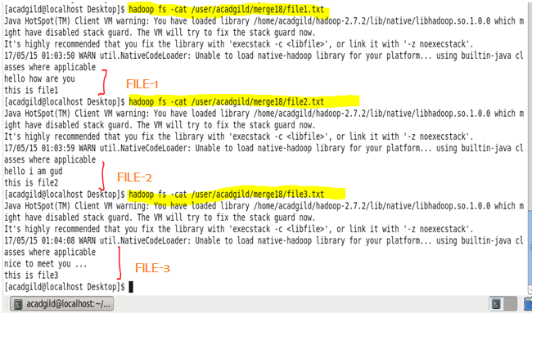

**File1, file2 and file3 are three different files we will use for merging.**

**Now Executing Merge Command-**

* **Merging files without new line-**

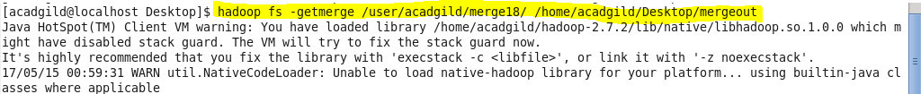

* **Merging files with new line between files-**

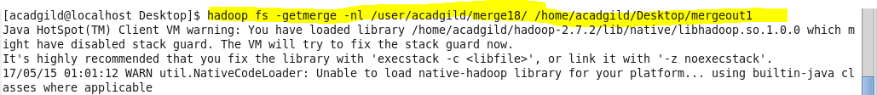

**Output-**

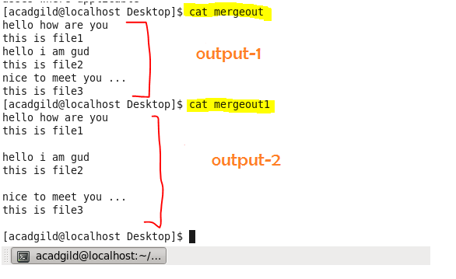

**Output-1 -> merged output without –nl (new line)**

**Output-2 -> merged output with –nl (new line)**